
1. Title
PDF Password Recovery Using Dictionary Attack with Hashcat

BY Kushal Dhakal

2. Objective
The objective of this lab is to extract a password hash from a protected PDF file and recover its password using a dictionary attack with the RockYou wordlist using Hashcat.

3. Tools Used
- Kali Linux
- Hashcat
RockYou wordlist (/usr/share/wordlists/rockyou.txt)

4. Lab Setup
- Operating System: Kali Linux (VMware)
- Target File: crack_protected.pdf
- Wordlist: RockYou
- Attack Type: Dictionary Attack

Step 1: Verify PDF File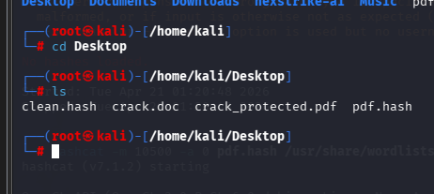

Step 2: Extract PDF Hash

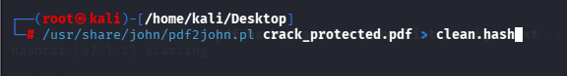

Step 3: Verify Hash File

Step 4: Clean Hash (if needed)
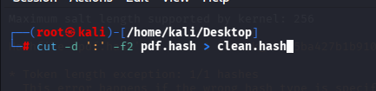
Step 5: Run Hashcat Attack
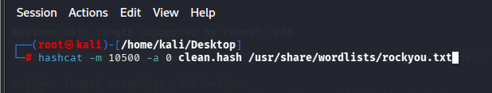

6. Result
The password was successfully cracked

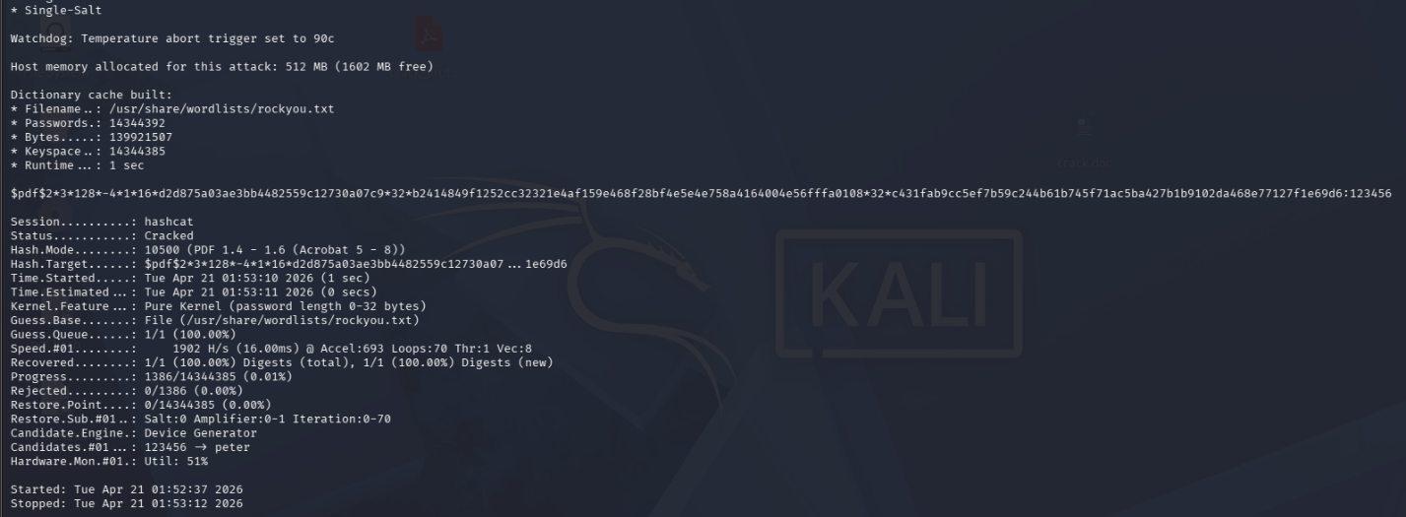

Cracked Password:

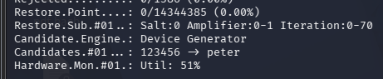
Password 123456

